NDL Layout Tool

Product BRD

March 2016

By: Hila Zimmerman

V1.0

Revision Table

| Ver. | Date | Updated by | Updated Sections | Comments |
| --- | --- | --- | --- | --- |
| **1.0** |  | **Hila Z.** |  | **New Document** |
|  | 23.5.16 |  |  |  |
|  |  |  |  |  |
|  |  |  |  |  |
|  |  |  |  |  |
|  |  |  |  |  |
|  |  |  |  |  |
|  |  |  |  |  |

Table of Contents

General idea 5

1. General layout 6

1.1. General size 6

1.2. Header 6

1.3. Main Content 7

1.4. Navigation Bar (Footer) 7

2. Arenas 8

2.1. Main section 8

2.2. Choose game for an arena space 9

2.3. Favorites 10

2.4. My Account 11

2.5. Top Games 12

2.6. VIP Games 12

2.7. Nav Bar options: 13

3. Games 14

3.1. Main section 14

3.2. Games editing screen 15

4. Save AS 18

4.1. Details 18

4.2. Main section 18

4.3. Nav Bar (Footer) 19

5. Dynamic layouts 20

5.1. Main section 20

5.2. Dynamic layout parameters 21

5.3. Nav Bar (Footer) 23

6. View mockup 25

6.1. Details 25

7. Save Draft 25

8. Save & Send 26

9. oTHER DETAILS 27

9.1. New brands 27

9.2. Exiting without saving 27

General idea

The layout tool will allow the casino product managers to edit the games & arenas layout throughout the NDL client. This tool will also allow to set new A/B test layout versions (and their test settings).

Partially working mockup can be found here: <http://blgp8v.axshare.com/>

1. General layout

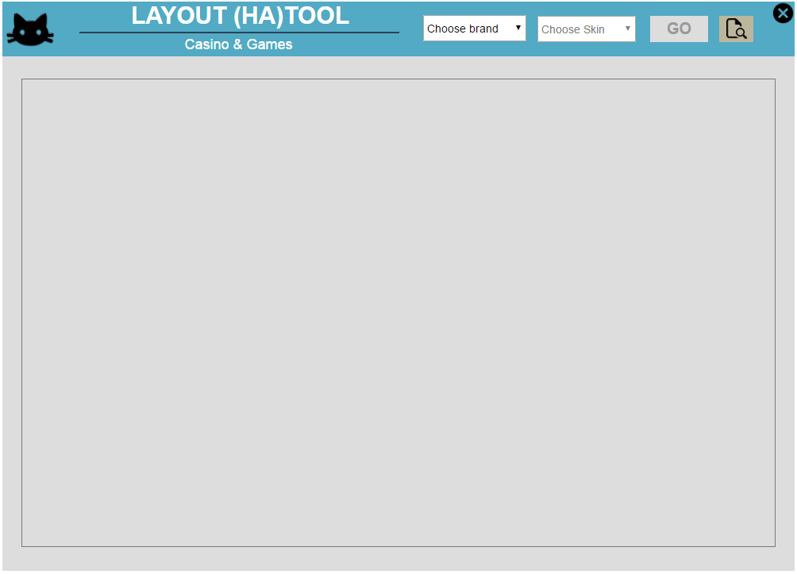

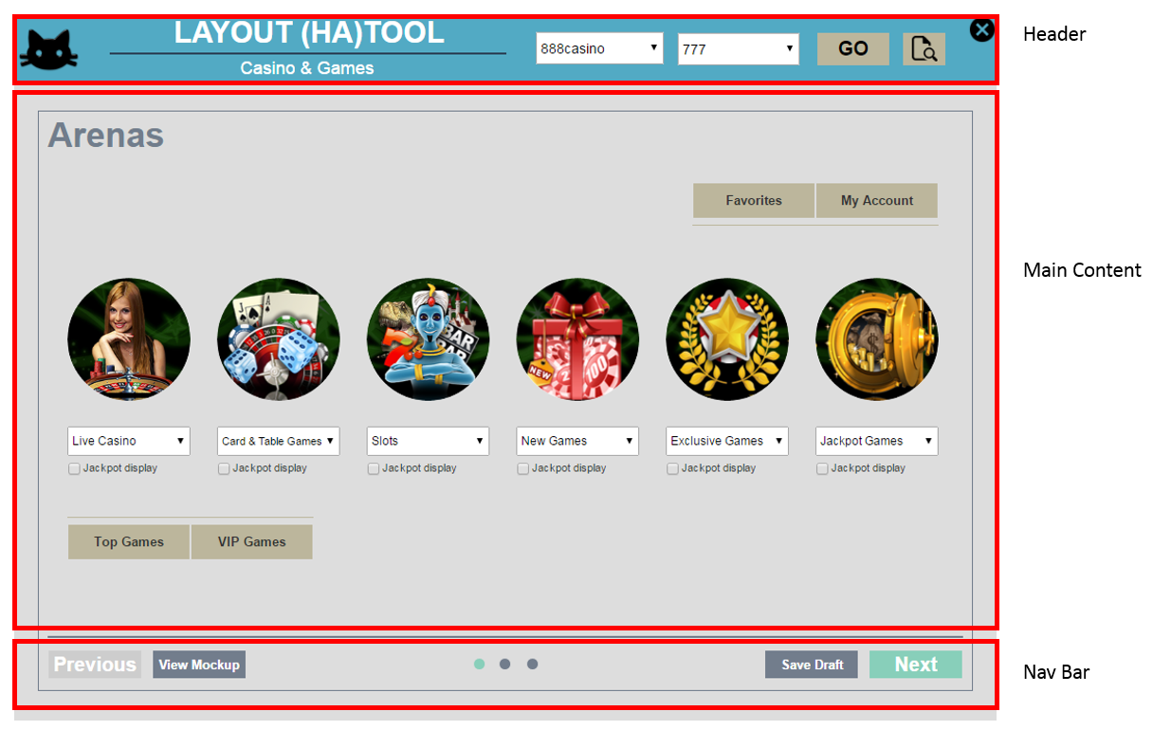

* 1. General size
     1. 1000x715px.
  2. Header
     1. Cat icon on the upper left corner.
     2. Main title: “Layout (HA)Tool”.
     3. Secondary title: “Casino & Games”.
     4. Dropdown menu to choose **brand** – should automatically contain all possible casino brands.
        1. As soon as the brand was chosen, the **skins** dropdown menu would be enabled (disabled by default) – should automatically contain all possible skins that are relevant for the previously chosen casino brand.
           1. As soon as the Skin was chosen, the “GO” button will be enabled. Clicking it will open up the Main part of the tool, loading the current layout found in that brand+skin combination in production.
     5. GO button – disabled by default, enabled when the user chose a value in the both the brand and the skin drop down menus.
     6. Browse icon – allowing the user to manually load a layout file to the tool.
     7. X button to close the tool (without saving).
  3. Main Content
     1. Content frame below the header, sized 950x590px.
     2. Page title (changing on user selection).
     3. Main content (changes according to page).
  4. Navigation Bar (Footer)
     1. Page indicators (the 3 small circles indicating in which stage the user is in).
     2. Next / Previous buttons.
     3. Other controls that change, according to the current page content.

1. Arenas

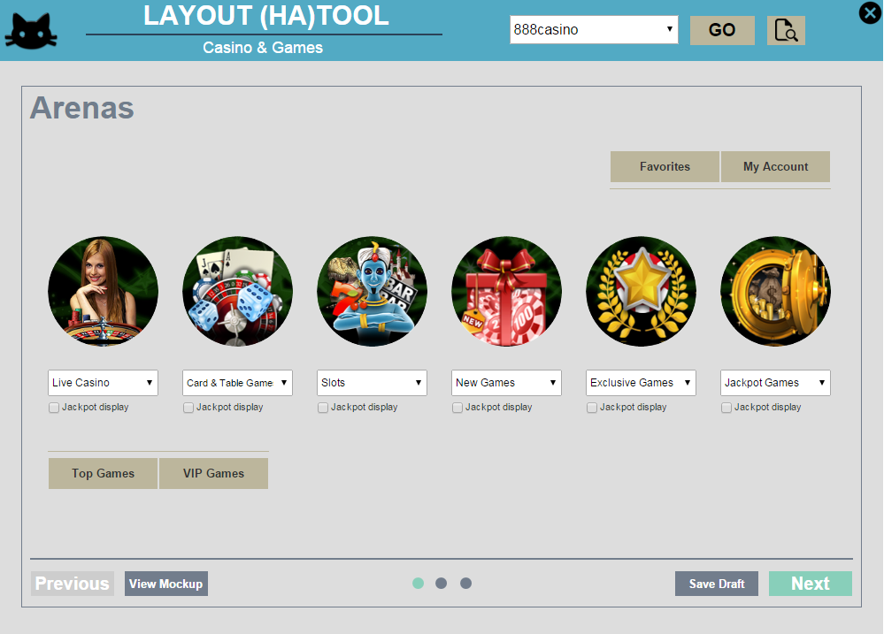

* 1. Main section
     1. Arenas:
        1. The amount of available arenas is automatically set according to the chosen brand and skin (i.e., if the chosen skin is 777, the available arenas amount would be 4 and not 6 as seen in the mockup).
        2. **Image** – Changes according to the user’s choice of arena in the drop down below it.
           1. A click on the image acts like the “next” button in this page, but additionally opens the relevant arena games section. So i.e., if clicked on the “slots” image, the user will get the Games page, with the Slots area open in it.
        3. **Dropdown list** – listing the possible arenas to choose from, from a pre-defined list of options, relevant to that skin.
           1. In addition to the pre-define list of options, there will be an option to choose a specific game that will take the arena’s place. Details about this screen in the following sections.
           2. The user can only choose each arena once – so as soon as he chooses one, it is not available to choose from in the other dropdowns. For that, please keep a blank option in each list.
        4. **Jackpots display checkbox** – used to determine whether the jackpots amounts for that arena will be displayed below it.
     2. Lobbies and menus:
        1. Seen on the top right and bottom left as tabs. These represent the games shown in different locations outside the arenas, such as the top games on the bottom left of the NDL.
        2. Each section has its tab. Details about these screens in the following sections.
  2. Choose game for an arena space

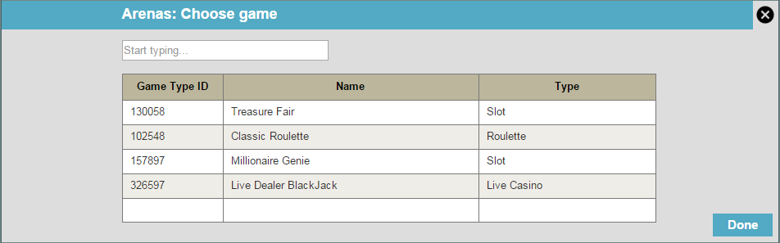

* + 1. As soon as the user chooses “specific game” from the arena dropdown list options, this screen would open up to allow him to choose which game.
    2. Size: 950x230px
    3. Title: “Arena: Choose Specific Game”
    4. “X” icon to close the window (without saving).
    5. “Done” button to save the user’s choice
    6. Search text box, with the text “Start typing”, as-you-type.
       1. This search box will search for any games according to Game Type ID, Game name or game Type.
    7. Data return table – returning all results according to the user’s input, narrowing them down as he types.
       1. Before starting to type in the search box, the table would be empty.
    8. Choosing a game would happen by clicking on the relevant game line, and then clicking “done”.
  1. Favorites

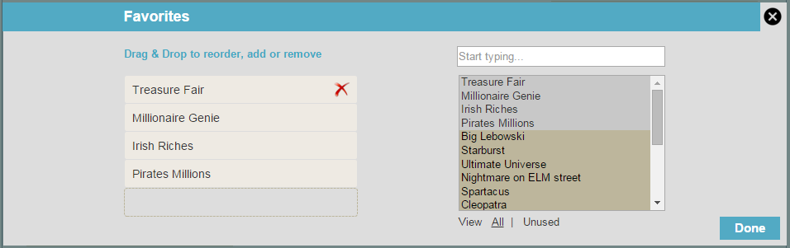

* + 1. Size: 950x230px.
    2. Title: “Favorites”.
    3. “X” icon to close the window (without saving).
    4. “Done” button to save the user’s changes.
    5. Left column
       1. Text: “Drag & Drop to reorder, add or remove”
       2. List of “chosen” games
          1. Mouseover on each game will show an X for removing it if needed  
             
          2. Games can be removed also by dragging and dropping them to the right column
          3. Max number of possible games to add would be set automatically according to the client settings in that skin.
    6. Right column
       1. Search box, as-you-type, for any of the available games to use in this section. The results will be shown in the list below it.
          1. Text: “Type game name…”
       2. List of all available games for this section.

By default, showing all relevant games for that section (until search box is used).

By default, displaying all games, including the ones used on the left side (“chosen” games), sorted by name, highlighting the “chosen” games with a different color.

Below the list, an option to change it from displaying all to displaying only unused (not chosen) games.

Picking games from that list and adding them to the left side would be allowed by drag & drop.

The list will allow multiple selection of items by holding down the CTRL key.

* 1. My Account

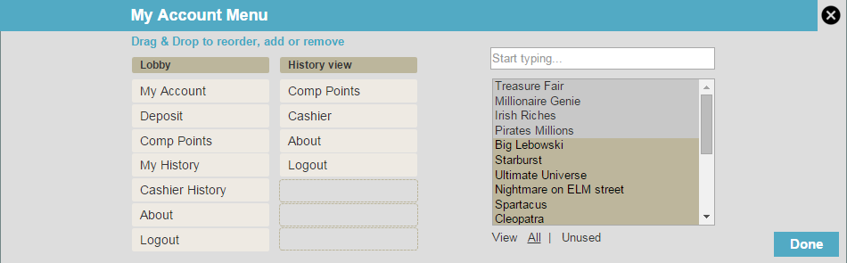

* + 1. Size: 950x230px.
    2. Title: “My Account Menu”.
    3. “X” icon to close the window (without saving).
    4. “Done” button to save the user’s changes.
    5. 2 Left columns
       1. Text: “Drag & Drop to reorder, add or remove”
       2. List of “chosen” items for each section (for the lobby and for the history page).
          1. Mouseover on each game will show an X for removing it if needed  
             
          2. Items can be removed also by dragging and dropping them to the right column
          3. Max number of possible items to add would be set automatically according to the client settings in that skin.
    6. Right column
       1. Search box, as-you-type, for any of the available items to use in this section. The results will be shown in the list below it.
          1. Text: “Start typing…”
       2. List of all available items for this section.

By default, showing all relevant items for that menu (until search box is used).

By default, displaying all items, including the ones used on the left side (“chosen” items), sorted by name, highlighting the “chosen” items with a different color.

Below the list, an option to change it from displaying all to displaying only unused (not chosen) items.

Picking items from that list and adding them to the left side would be allowed by drag & drop.

The list will allow multiple selection of items by holding down the CTRL key.

* 1. Top Games

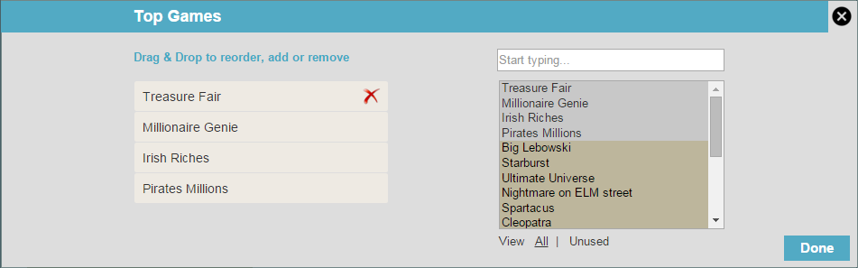

* + 1. Title: “Top Games”.
    2. All the rest is identical to “favorites” section.
  1. VIP Games

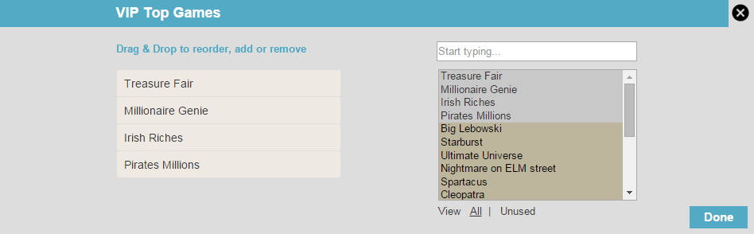

* + 1. Title: “VIP Games”.
    2. All the rest is identical to “favorites” section.
  1. Nav Bar options:
     1. Left side:
        1. Previous (disabled)
        2. View mockup - Details about this screen in the following sections
     2. Right side:
        1. Save draft - Details about this screen in the following sections
        2. Next – Switching to Games page

1. Games

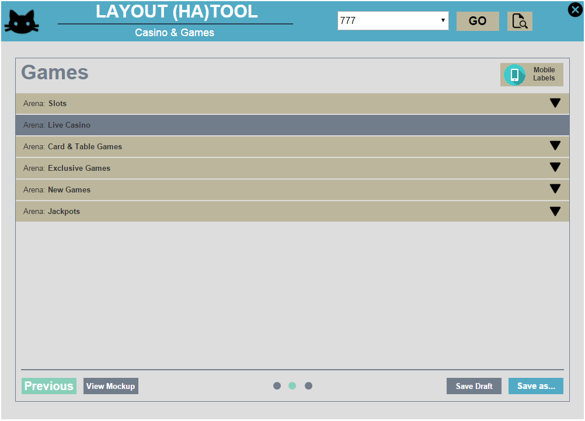

* 1. Main section
     1. Displaying the list of arenas set in the previous screen, each with its own line, name and down arrow to indicate that this part opens up below it.
        1. The “Live Dealer” arena line will not be available for editing and will be grayed-out.

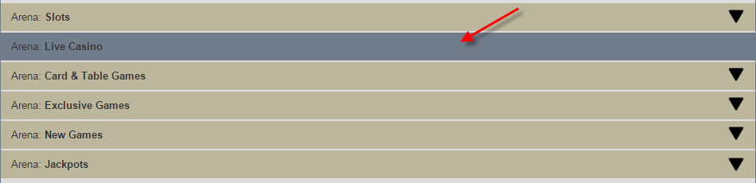

* + - 1. The list of arenas will be ordered by the same order that they were set in the previous Arenas page.
    1. Clicking each row (all along it, including the arrow) opens up the games changes screen.
    2. Upon opening one of the rows, that specific row would become the top one, and the rest of the rows would disappear.
    3. On the top right there’s a mobile labels button – if turned on, it will add the mobile label to all relevant games under that brand automatically. This is especially good for brands that do not have a mobile client, therefore we would like to remove the mobile indication off their games.
       1. 2 possible states:
          1. OFF: 
          2. ON: 
       2. Default is ON.
  1. Games editing screen

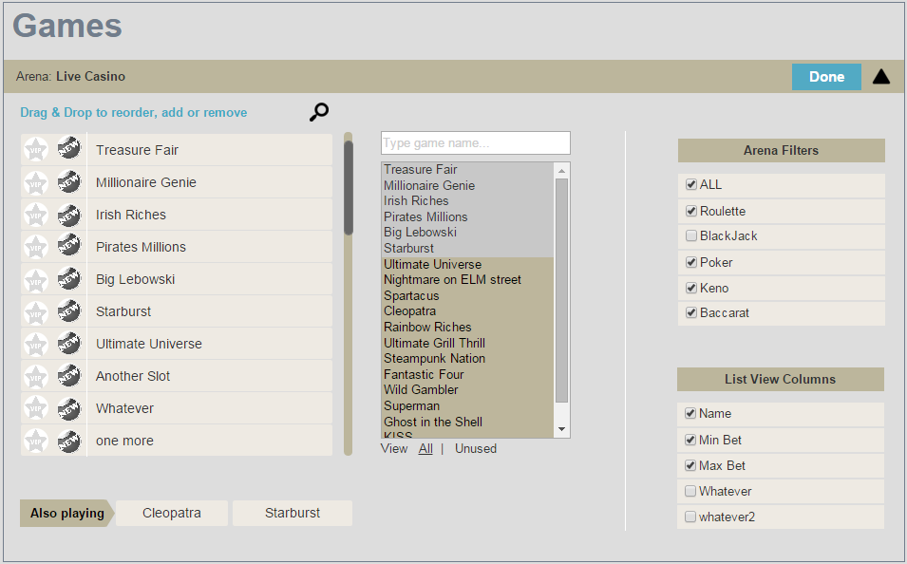

* + 1. Size: taking over the entire area below the clicked line.
    2. Once clicked to open, the line with the arena name will change its arrow to up (indication that the user can close that window back), and a “done” button would appear next to the arrow, allowing the user to save and finish working on this arena.
    3. **Left column**
       1. **Top text**: “Drag & drop to reorder, add or remove”.
       2. **Search icon**, to find a specific game in that list (meaning, searching only within that list of chosen games on the left)
          1. Searching would retrieve the same list structure with the relevant results (as-you-type).
       3. **List of all games** (all that are currently in production in that specific arena)
          1. Labels: For each games, there are 2 labels, represented as icons. These labels can be turned on or off by a clicking, switching between grayed out (off) to full color (on). The labels would initially be on/off according to production.

Game is available for VIPs

Game is new

* + - * 1. Game Name
        2. On mouseover: “X” icon to delete/remove that item from the list



Removing items from the list would also be possible by drag & drop to the right side column list.

* + - * 1. Scroll bar, to scroll through all games that are currently in this arena
        2. Changing the order of the games would work by a “drag & drop”.
        3. Between every 10 games there will be a visual separator to indicate that they will appear on separate pages:

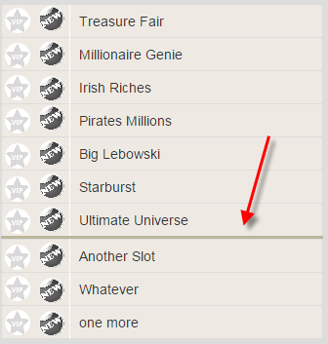

* + - 1. **Also playing section**
         1. Title: “Also Playing”
         2. 2 areas for games to be displayed in that arena, on the right side “also playing” section.
         3. On mouseover: “X” icon to delete/remove that item from the list



Removing items from the list would also be possible by drag & drop to the right side column list.

* + - * 1. Changing the order of the games would work by a “drag & drop”.
        2. The games in this section will automatically get the labels set for them on the full list above it.
    1. **Center column**
       1. **Search text box**, with the text “Type game name…”
          1. This search box will search for any games relevant to that arena only (i.e. for the slots arena, it will only search for slots), and display the results in the list below, as-you-type.
       2. **List of games**
          1. By default, showing all games relevant for that arena (until search box is used).
          2. By default, displaying all games, including the ones used on the left side (“chosen” games), sorted by name, highlighting the “chosen” games with a different color.
          3. Below the list, an option to change it from displaying all to displaying only unused (not chosen) games.
          4. Picking games from that list and adding them to the left side would be allowed by drag & drop.
          5. The list will allow multiple selection of items by holding down the CTRL key.
    2. **Right column**
       1. **Arena Filters**
          1. Checkboxes to choose the filters for the arena games.
          2. The order of the items can be changed by drag & drop.
          3. The list of options changes according to the relevant arena (i.e. number of pay lines would appear only on the slots arena filters). That list is pre-defined.
       2. **List view columns**
          1. Checkboxes to choose the list view columns for the arena games.
          2. The order of the items can be changed by drag & drop.
          3. The list of options changes according to the relevant arena (i.e. number of pay lines would appear only on the slots arena filters). That list is pre-defined.
    3. **Nav Bar options** (not visible when the games editing section is open):
       1. **Left side:**
          1. Previous – switching to Arenas page
          2. View mockup - Details about this screen in the following sections
       2. **Right side:**
          1. Save draft - Details about this screen in the following sections
          2. Save as - Details about this screen in the following sections

1. Save AS

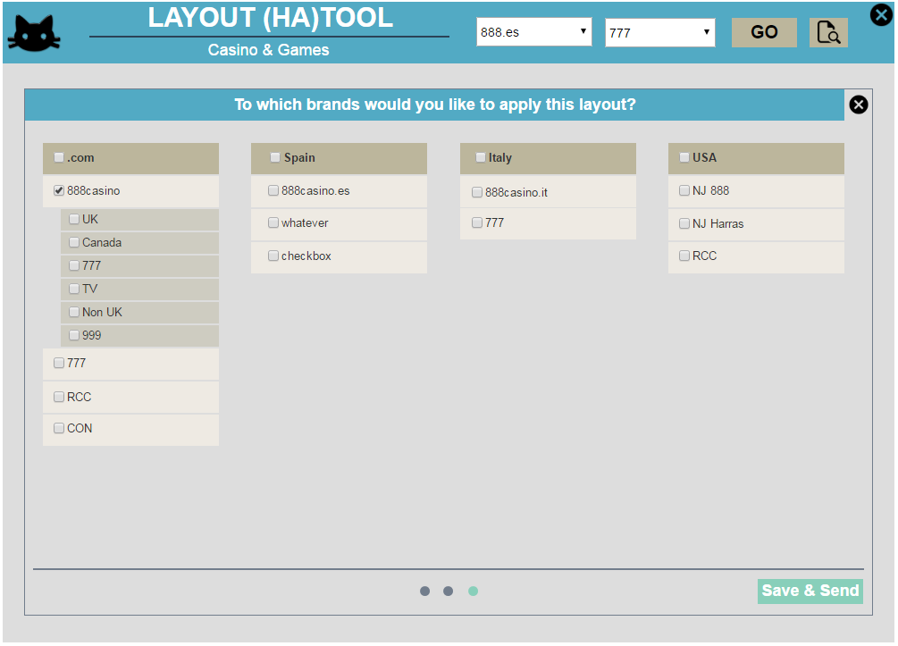

* 1. Details
     1. This screen allows the user to save his layout to any of the casino skins. For any checked SKIN, the user will get the option to define dynamic layouts (settings icon will be enabled).

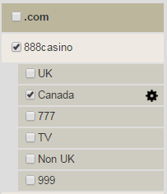

* 1. Main section
     1. Title: “To which brands would you like to apply this layout?”
     2. X icon to close this screen (without saving) – will close the saving screen and will go back to the Games lobby.
     3. List of checkboxes of ALL casino brands available, sorted by regulations.
        1. When a brand is checked, the list of relevant available skins would be displayed below it.
        2. By default, the brand and all skins related to it will be checked according to the brand that was initially chosen in the header dropdown menu at the beginning of the process.
        3. By default, when a brand is checked by the user, all skins below it will also be checked. If necessary, the user can un-check the irrelevant skins.
        4. For each regulation group, the user can check the regulation title to mark all under it as checked (will include all brands and skins).
        5. When a skin’s box was checked, the settings icon next to it will become available, allowing him to define dynamic layouts for it. This will only be available on a skin level, and not on a brand level.  
            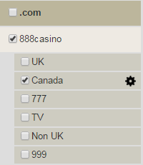
        6. Details about the dynamic layouts screen in the following sections.
  2. Nav Bar (Footer)
     1. Right side:
        1. Save & send
           1. Saves the layout(s) locally to a pre-defined location
           2. Saves the layout(s) on the network to a pre-defined location
           3. Sends the layout(s) (or a notification about it) to a pre-defined factory configurator.
           4. Details about this screen in the following sections.

1. Dynamic layouts

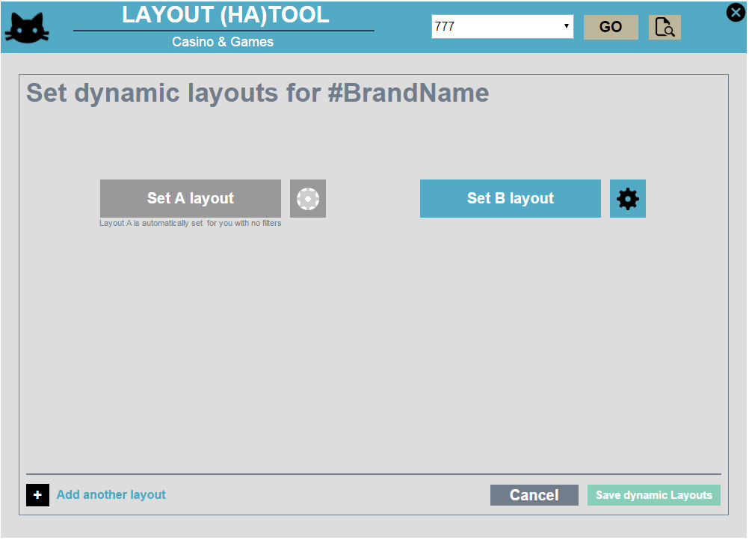

* 1. Main section
     1. Title: Set Dynamic Layouts for #BrandName (# is a changing parameter)
     2. For each layout version, a “Set layout” button, and a settings button.
        1. Set version layout
           1. Opens up the first screen (Arenas) to allow the user to change the layout on it, and switch to the Games page for changes as well. The “save as” button in the games page will change to “save”, and once clicked will close this area and send the user back to the dynamic layouts screen.
        2. Settings (layout parameters)
           1. Details in the following sections.
     3. By default, version A will be disabled, and it will automatically include the previously set layout, and will have not specified parameters to it.
     4. Each saved section, will turn gray as soon as it is saved. i.e., the user clicked the settings icon on the B layout (which is now blue), as soon as he finishes it and saves, it becomes gray. This is to indicate that it was done and help the user remember what else is left to be taken care of.
  2. Dynamic layout parameters

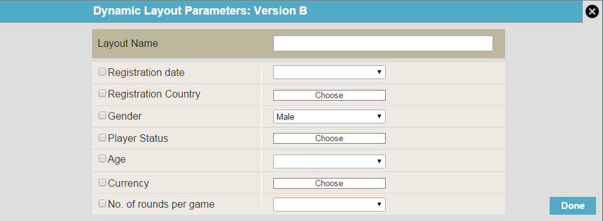

* + 1. Title: “Dynamic Layout Parameters: Version #”
    2. List of checkboxes of parameters, and the relevant fields next to them. The fields on the right are disabled until a box is checked:
       1. Layout name
          1. Simple text box
       2. Registration date
          1. Dropdown menu – for each choice, the user will get a date picker to choose from  
             

Before

Between

After

* + - 1. Registration country
         1. A button that opens a list of countries. This list allows multiple choice by holding down the CTRL key. The list closes by clicking the button again.  
            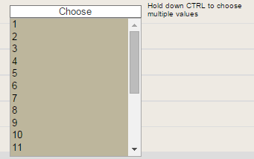
         2. Once this parameter checkbox is checked, a text will be added to the right side of the “choose” button: “Hold down CTRL to choose multiple values”
      2. Gender
         1. A dropdown list of 2 options (if the user wants both, he should just uncheck the “gender” option).
      3. Player status
         1. A button that opens a list of possible statuses. This list allows multiple choice by holding down the CTRL key. The list closes by clicking the button again.  
            
         2. Once this parameter checkbox is checked, a text will be added to the right side of the “choose” button: “Hold down CTRL to choose multiple values”
      4. Age
         1. Dropdown menu – for each choice, the user will get a small text box to enter the age  
            

Under

Between

Older than

* + - 1. Currency
         1. A button that opens a list of possible currencies. This list allows multiple choice by holding down the CTRL key. The list closes by clicking the button again.  
            
         2. Once this parameter checkbox is checked, a text will be added to the right side of the “choose” button: “Hold down CTRL to choose multiple values”
      2. No. of rounds per game
         1. Dropdown menu – for each choice, the user will get a small text box to enter the number  
            

Under

Between

More than

* + 1. “Done” button to save and close the screen.
  1. Nav Bar (Footer)
     1. Left side:
        1. Plus icon with the text “Add another layout”, allowing the user to add more dynamic layouts.
     2. Right side:
        1. Cancel – closing the dynamic layouts screen, without saving.
        2. Save dynamic layouts – saving the user’s settings and going back to the “save as” screen.
           1. This button will become enabled only as soon as the user has defined and saved all open layouts. i.e., if the user has 3 layouts, all 3 should be finalized and saved before this button becomes enabled. If the user only needs 2, he should remove one layout (in the delete button) and then save.

1. View mockup
   1. Details
      1. The mockup should allow the user to view the new layout on the client itself.
      2. The screenshot seen in the link is only an example and should not be considered as a solution.
      3. Dev to decide how this should be executed – either by opening a mock-NDL version, by providing a look-alike layout without the graphics etc.
2. Save Draft

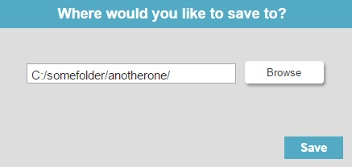

* + 1. Size 440x210px
    2. The draft will be saved locally to a predefined folder. The tool will automatically name the layout with the brand + skin names, date and version number.
    3. Saving the draft multiple times on the same session, will override the previous version saved. (Session – the user opened the tool and did not change the brand and/or skin in the header dropdown).
    4. Title: “Draft saved!”
    5. Content: the path to which the draft was saved.
    6. “Done” button to close the popup and continue working.

1. Save & Send

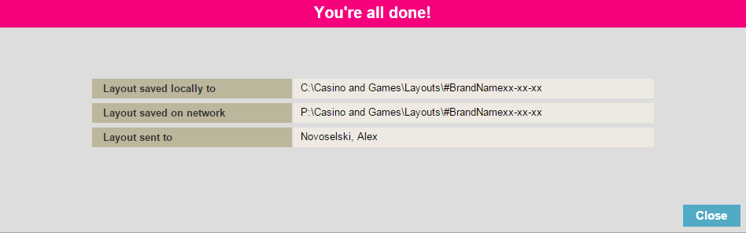

* + 1. This screen appears after clicking “save & send” on the “Save As…” screen.
    2. Title: “You’re all done!”
    3. Content:
       1. 3 rows to tell the user what was done with the layout – local location, network location and who it was sent to via email.
    4. “Close” button to close the screen, and go back to the original tool screen, where the main content was still hidden.

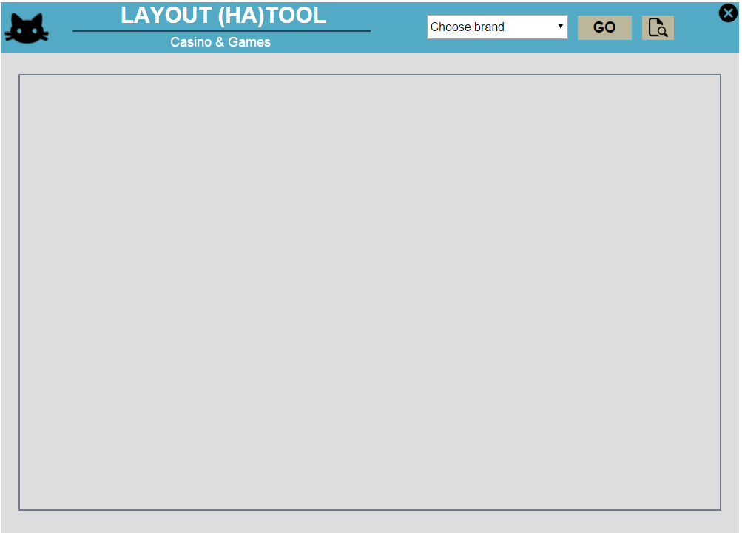

1. Other Details
   1. New brands
      1. In case the user wants to apply a layout to a new brand / Skin, he can either:
         1. Choose it in the header dropdown, and fill in all the details manually (all fields will be empty as there will be nothing in production)
            1. *TBD: Can instead take the default previously set, such as 888casino.com layout. Should be determined by Ofir / Or.*
         2. Open another brand’s layout, make the necessary changes, and choose the new brand in the “save as” screen.
   2. Exiting without saving
      1. In case the user attempts to close the tool without saving, a warning popup will show up:

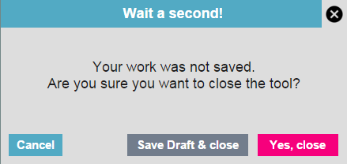

* + - 1. Title: “Wait a second!”
      2. Text: “Your work was not saved. Are you sure you want to close the tool?”
      3. X icon to close this message and go back to the tool.
      4. “Cancel” closes this message and goes back to the tool.
      5. “Save Draft & close” opens up the “save draft” box.
         1. Clicking “Save” saves the drafts and closes the tool.



* + - 1. “Yes, close” closes the tool without saving.